ASSIGNMENT 14

B.vaishnavi

2403A52408

Task 1: AI-Assisted Portfolio Website

PROMPT:

Use this to paste if you prefer a short prompt:  
"Create index.html and styles.css for a responsive, accessible personal portfolio (Home, About, Projects grid, Contact). Use semantic HTML, mobile-first CSS (flexbox/grid), CSS variables, keyboard-focusable project cards with a hover/focus lift and overlay revealing Live/Code links, and respect prefers-reduced-motion—output only the two file contents

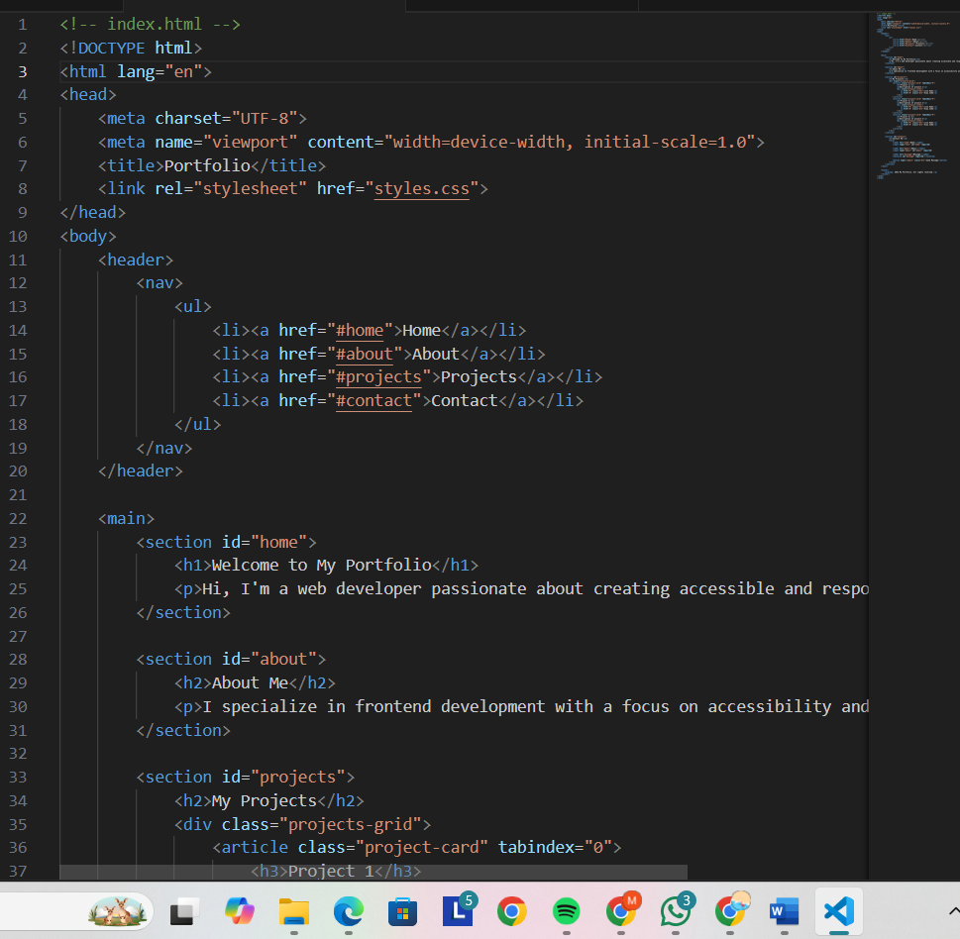

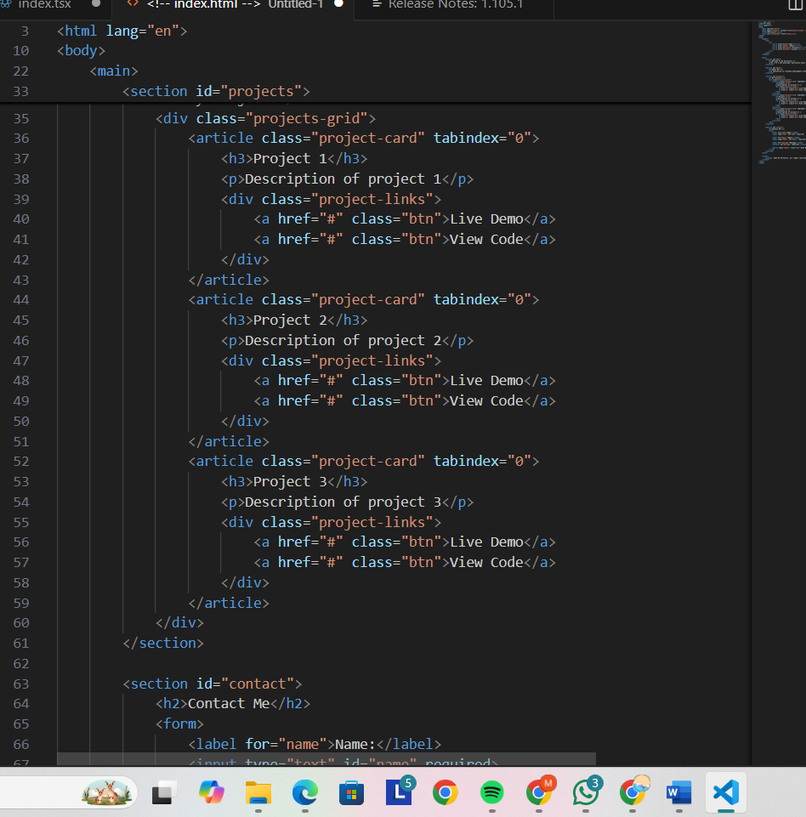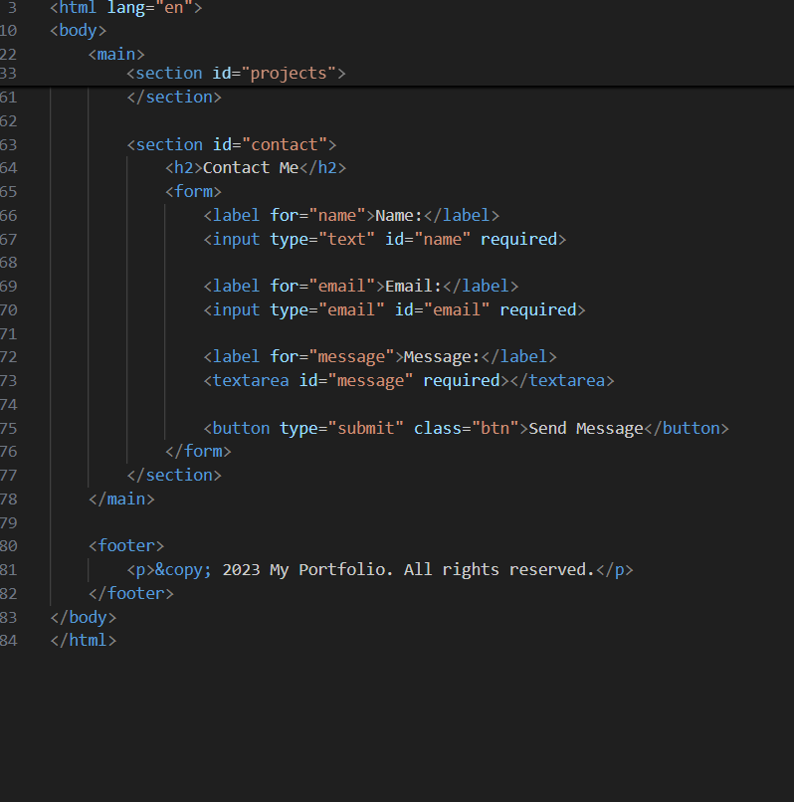

OUTPUT:

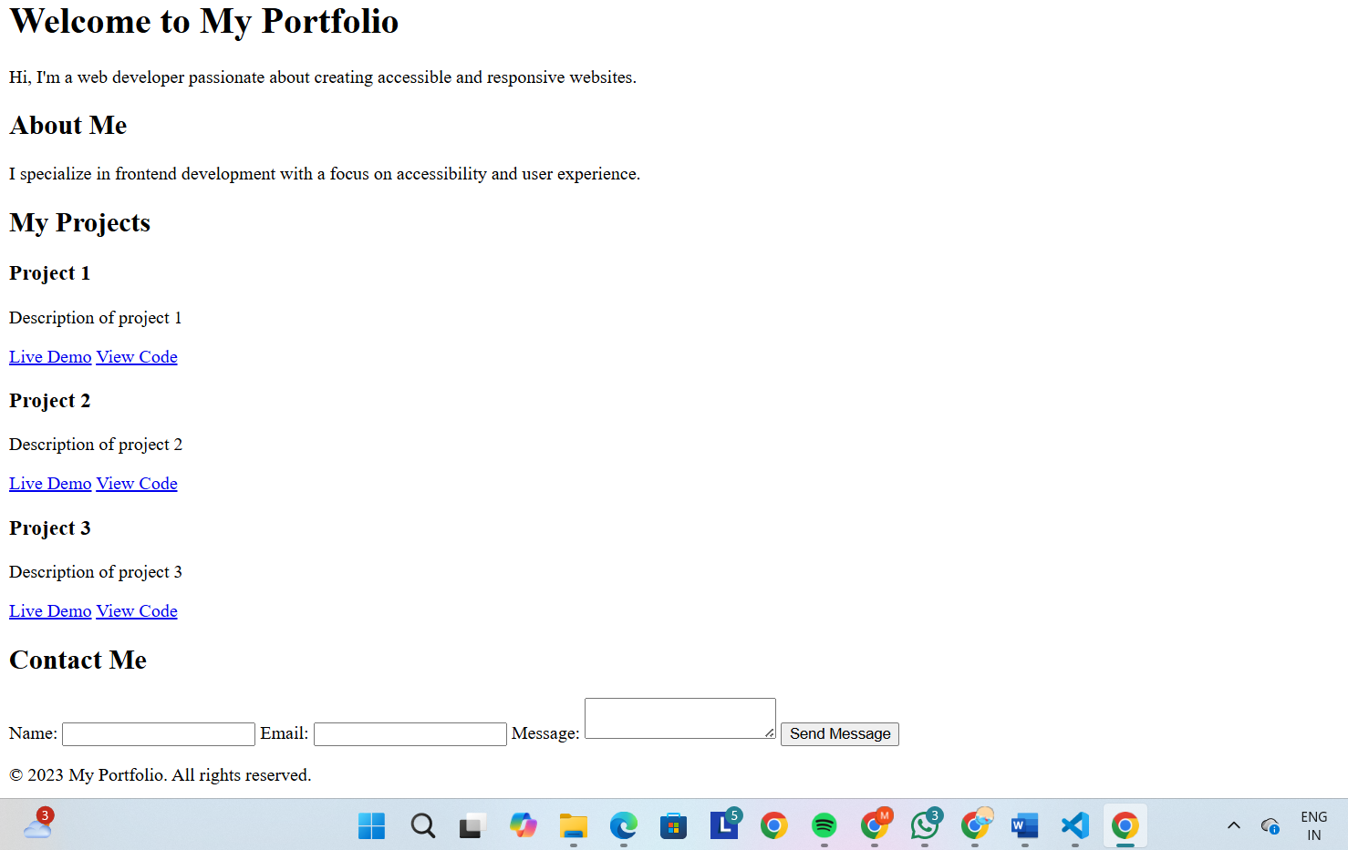EXPLANATION:

Generate index.html and styles.css for a responsive, accessible portfolio (Home/About/Projects/Contact) using semantic HTML, mobile-first CSS (flex/grid + CSS variables), keyboard-focusable project cards with a hover/focus lift and overlay revealing Live/Code links, respect prefers-reduced-motion — output only the two files.

Task 2: AI-Generated Restaurant Landing Page

PROMPT: "Create index.html, styles.css, and script.js for a restaurant landing page with a responsive nav (Home/Menu/Gallery/Contact), menu cards (6 items), and a JS image slider (prev/next, dots, autoplay, keyboard support); output only the three full file contents."

CODE: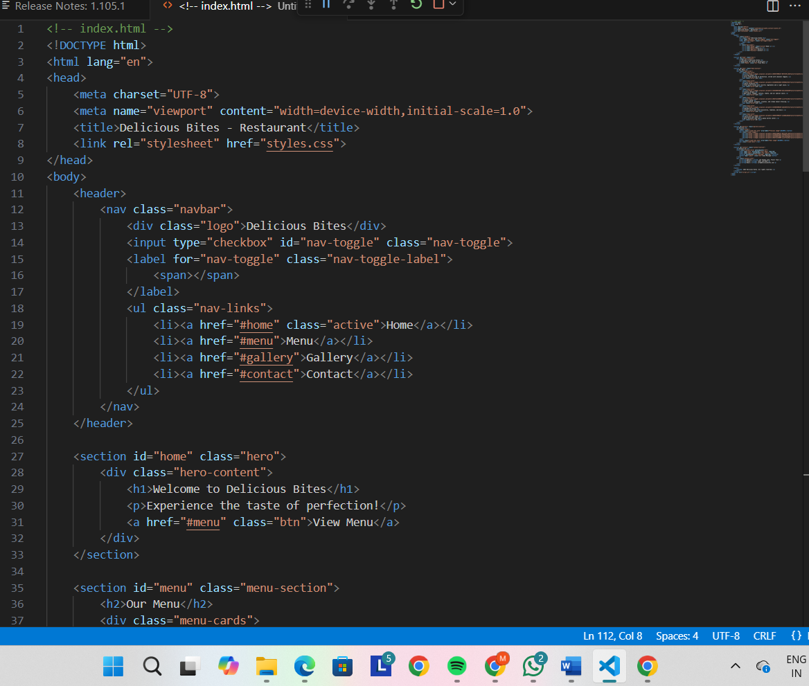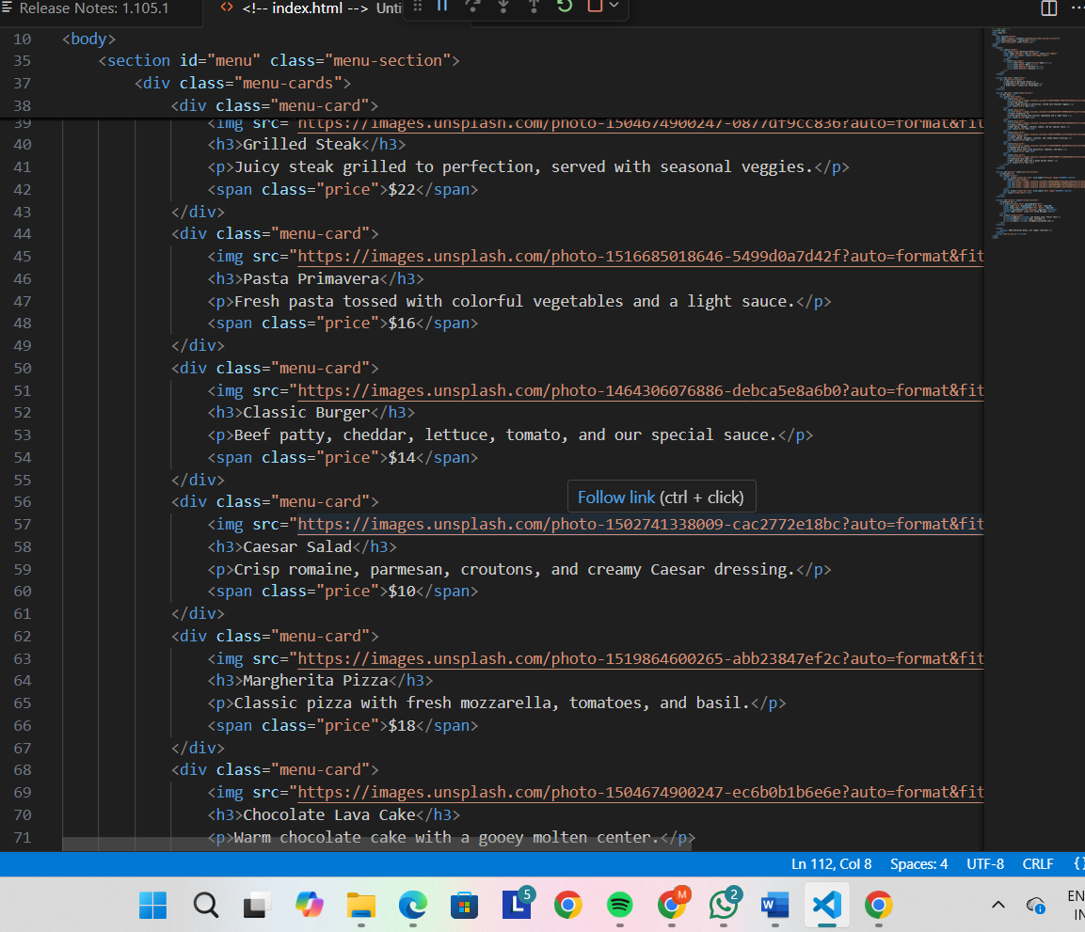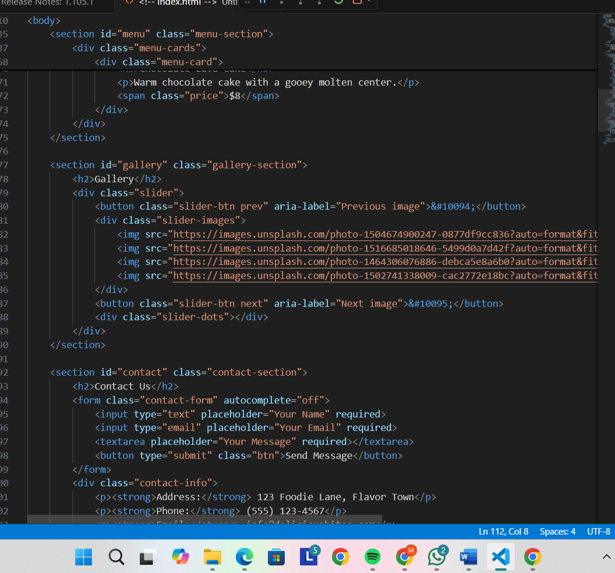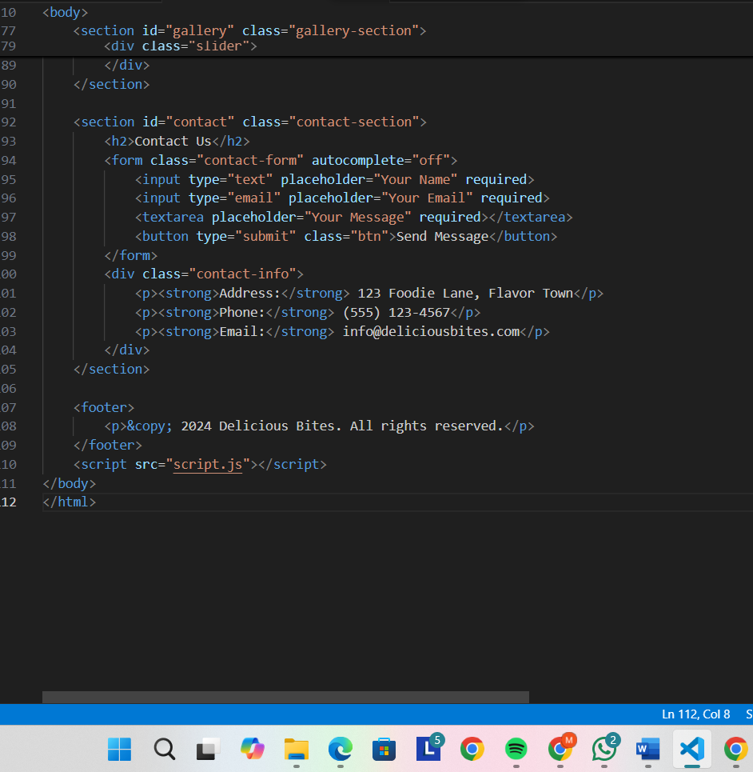

OUTPUT:

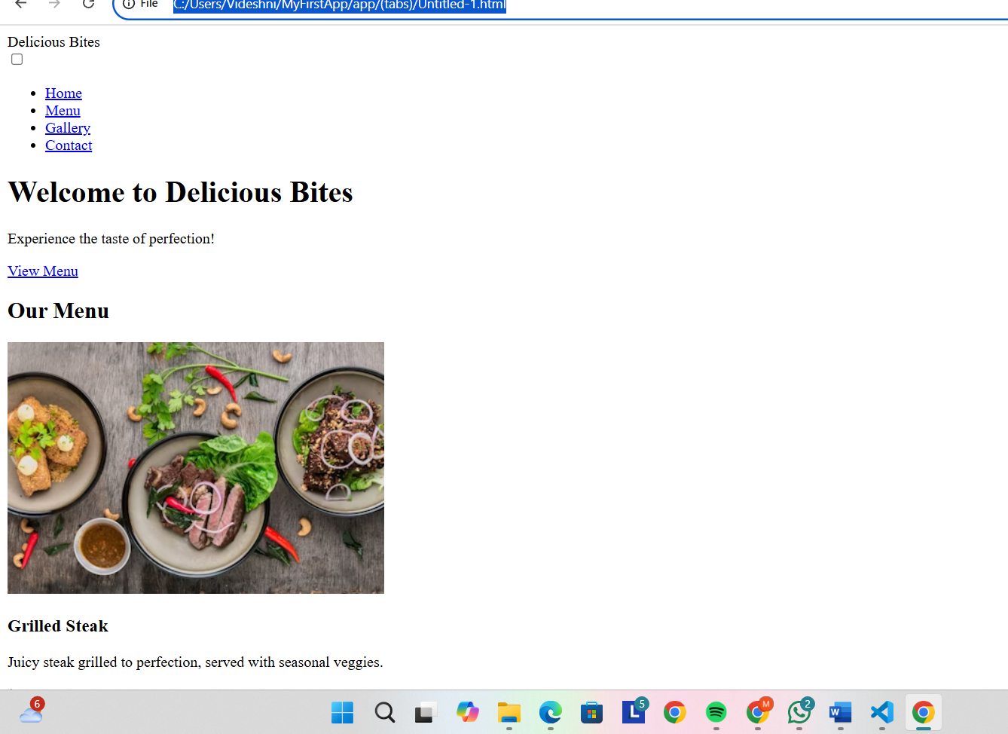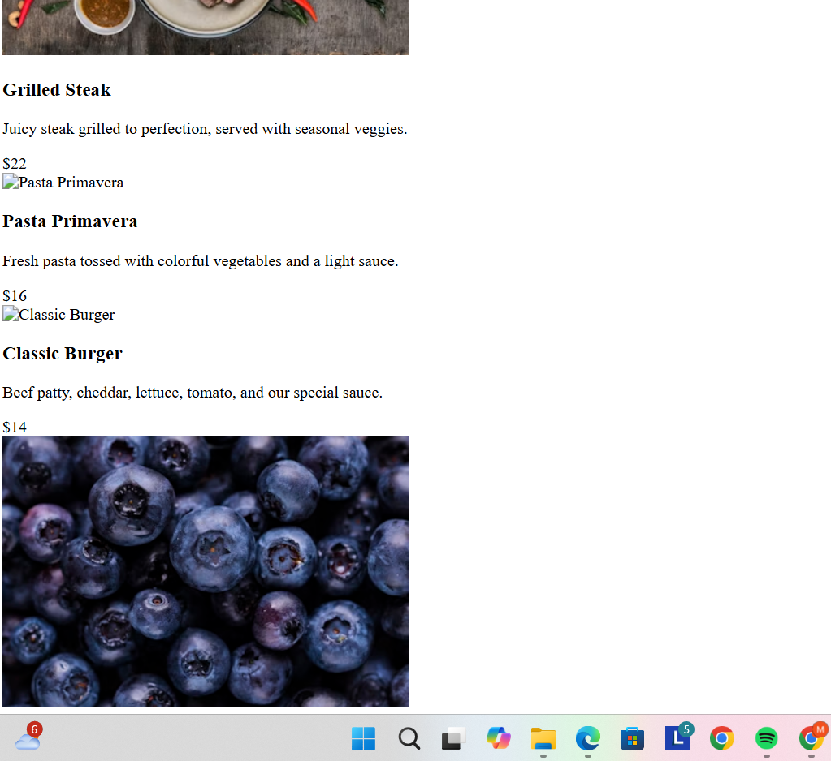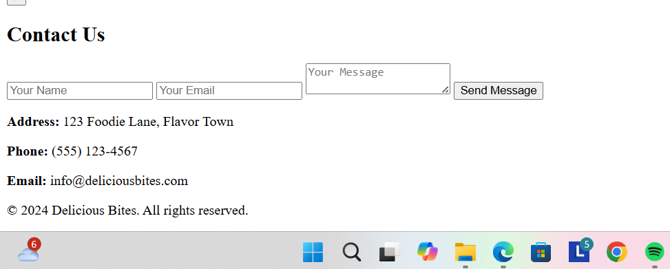

EXPLANATION: Generate index.html, styles.css, and script.js for a responsive restaurant landing page with Nav (Home, Menu, Gallery, Contact), 6 menu cards (grid), and a JS image slider (prev/next, dots, autoplay, keyboard support); output only the three full file contents.

Task 3: AI-Powered Event Registration Form

PROMPT: Generate index.html, styles.css, and script.js for an SR University Tech Fest registration form (fields: Name, Email, Phone, Department, Event Selection). Use accessible, mobile-first CSS for an attractive layout and vanilla JS for real-time validation (email format, phone length, required checks, inline error messages, disable submit until valid). Output only the three full file contents.

CODE: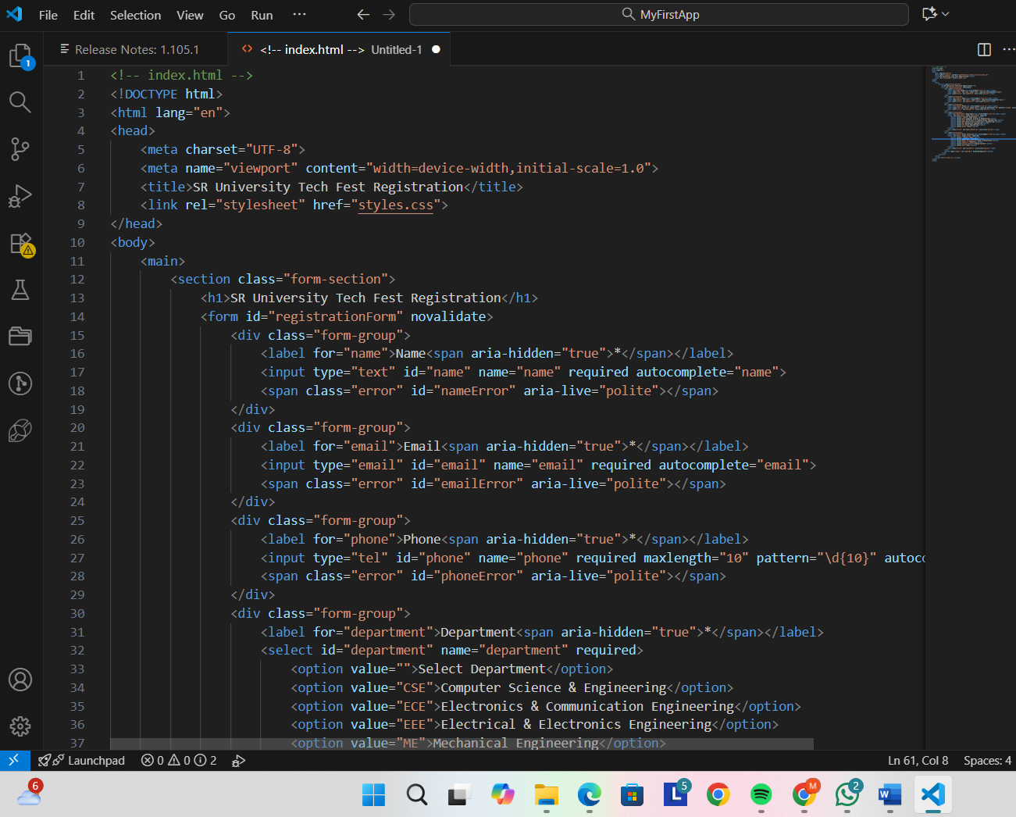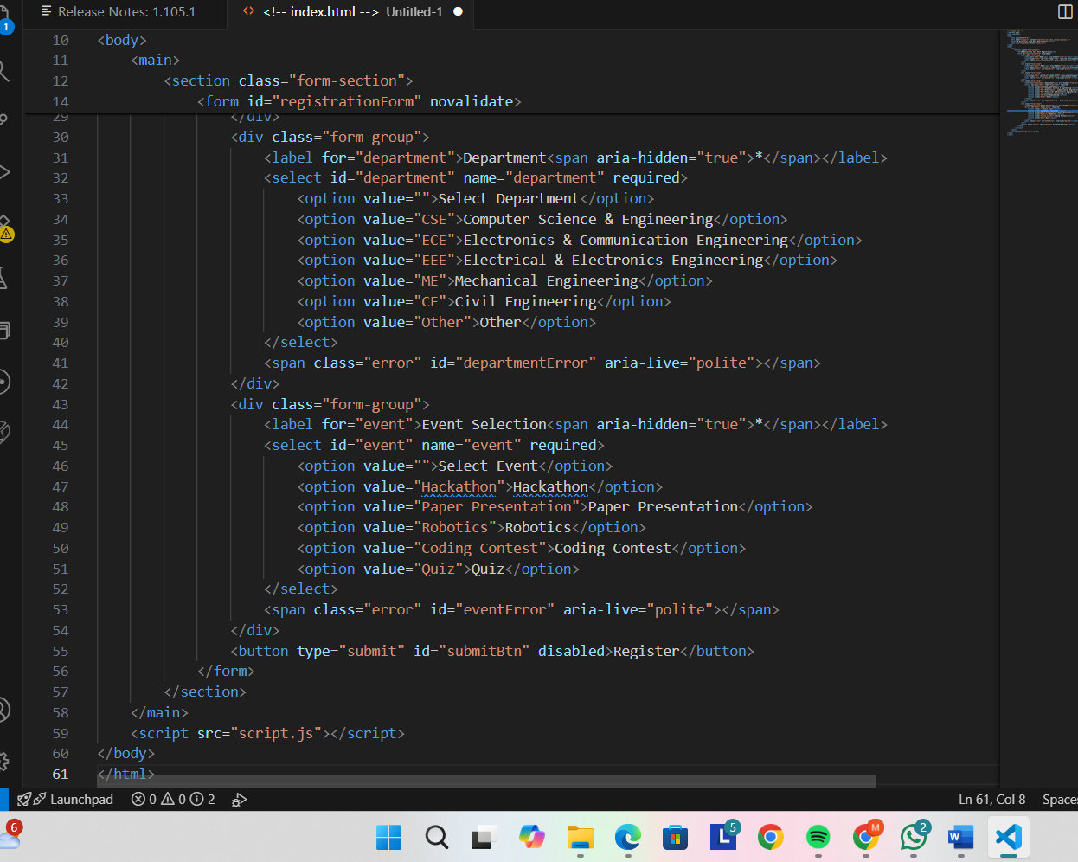

OUTPUT:

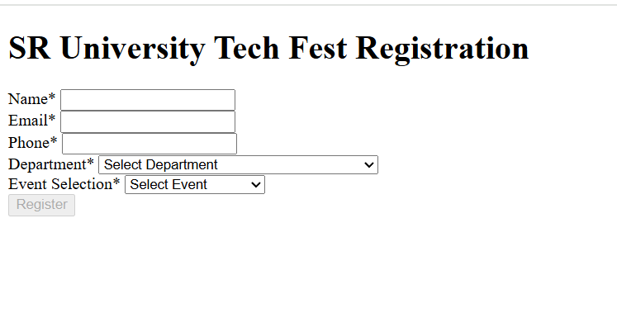

* EXPLANATION: Files: index.html, styles.css, script.js
* Fields: Name, Email, Phone, Department, Event
* CSS: mobile-first, neat form cards
* JS: real-time checks (email format, phone length, required)
* UX: inline errors, disable submit until valid
* A11y: labels, focus styles, aria where needed
* Output: only the three full files (no extra text)

Task 4: AI-Assisted E-Commerce Product Page

PROMPT: Create index.html, styles.css, and script.js for a responsive product catalog: a grid of product cards (image, title, price, "Add to Cart" button), mobile-first CSS, and vanilla JS that implements Add-to-Cart updating a top-right cart counter (persist in localStorage), accessible markup and keyboard support — output only the three full file contents.

CODE:

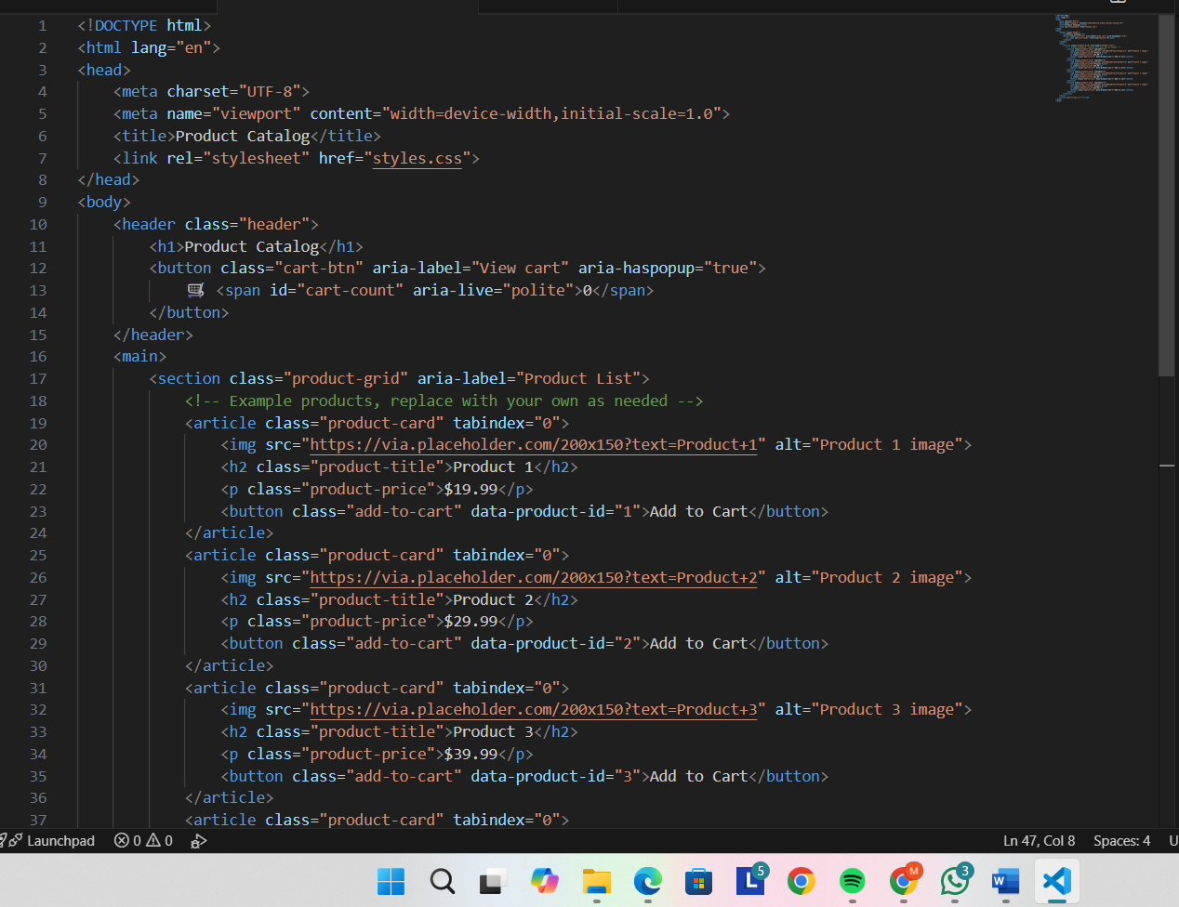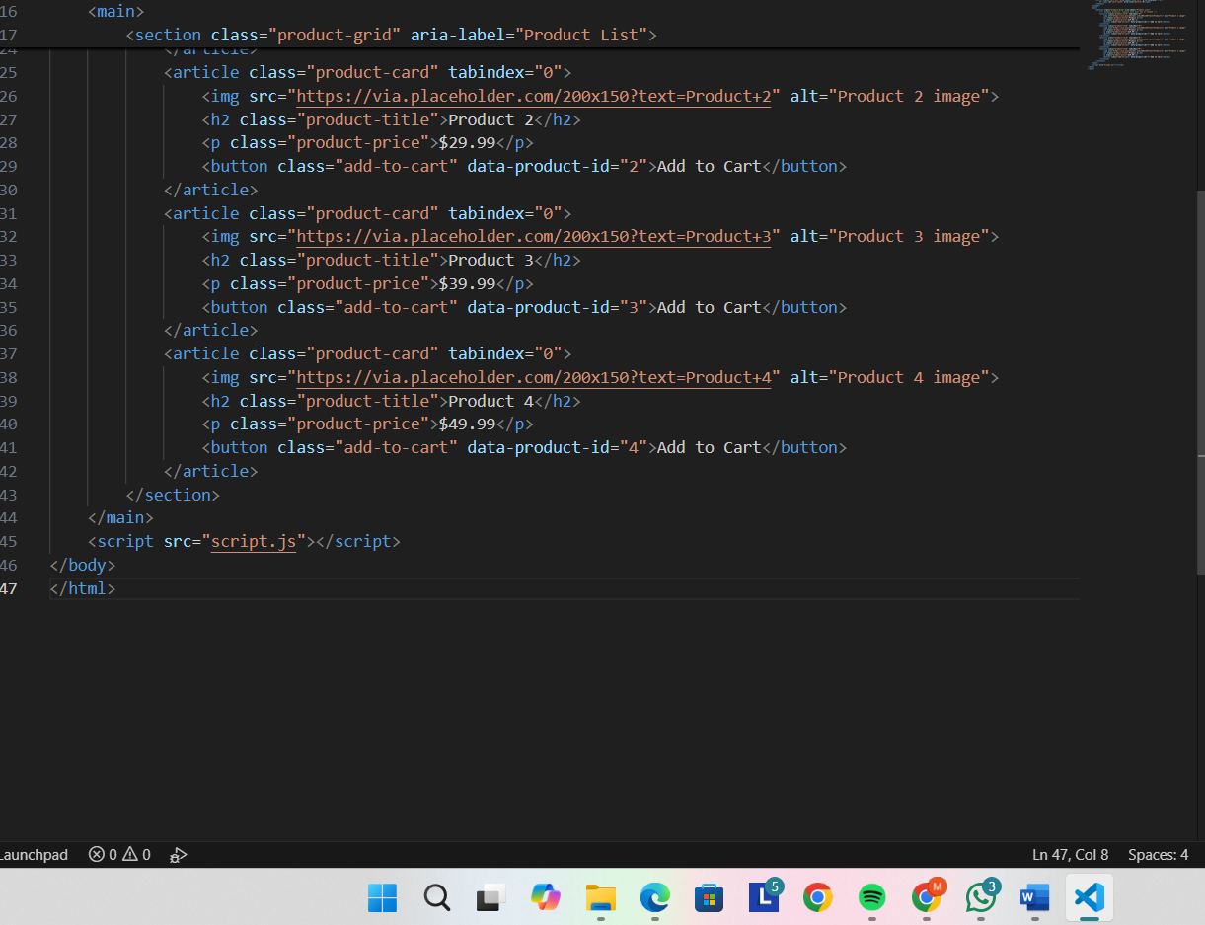

OUTPUT:

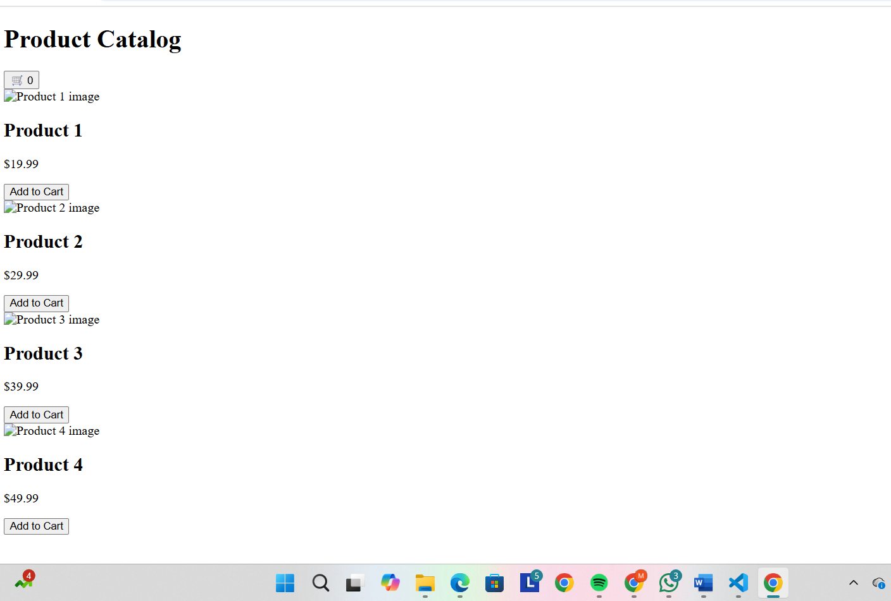

EXPLANATION:

* Files: index.html, styles.css, script.js
* Layout: responsive product grid (cards)
* Card: image, title, price, "Add to Cart" button
* JS: add-to-cart updates counter, stores in localStorage
* Counter: top-right persistent cart badge
* Accessibility: buttons keyboard-focusable, ARIA labels
* Test: click Add, refresh (counter persists), keyboard nav